Q-Agent

User’s Guide

Version 1.3

Table of contents

Overview 3
Manage Time 4
Customer management 6
Banking 8
Accounts 9
View Employees, Vendors and Item 10
Setup 11
Quick Synchronization with QuickBooks® Online Edition 12

Overview

If you are QuickBooks® customer and using QuickBooks® Online this solution intended for you. It allows you to keep and manage your accounting data from the Pocket PC device wherever you go. You can manage time sheets, create invoices, make banking operations and even more. At any time you can synchronize handheld data with your Quick Books Online account straightly from the Pocket PC without using desktop computer via WiFi, GPRS or another available connection. Q-Agent runs on Pocket PC 2003, Windows Mobile 5.0 and later.

Manage Time

This hub allows you to track time and bill customers in the same way as QuickBooks® Online Edition. Single activity time sheet gives you ability to record single time entry. Weekly time sheet provides access to all time reports grouped by week and entity (vendor or employee). By using single activity time sheet you can add the new time entry only.

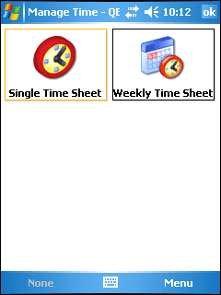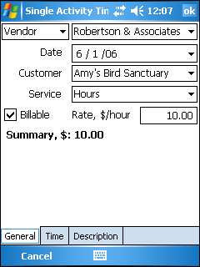

In Weekly time sheet you can select certain Employee or a Vendor and specify a week to view all time activities for this week. Also you can see billable amount and total time for each day of week and for whole week. You can add, edit or delete single time entry from Weekly time sheet by selecting specific day of week and tapping menu action.
Left column shows the status of time entry. "S" - Synchronized, "C" - created. After next synchronization session all the new created time entries will be uploaded and will have synchronized statuses. You cannot edit and delete synchronized entries but you can do this with just created entries.
"Copy" function allows you to create the new time entry with the settings copied from the old one, but you can change any data as well.
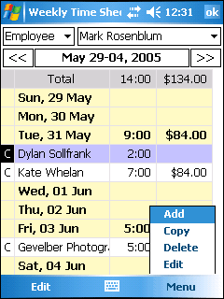

Customer management

Customer management hub shows you list of customers and their current balance. Enter the first letters of the customer's name into the quick search field to find a certain customer.

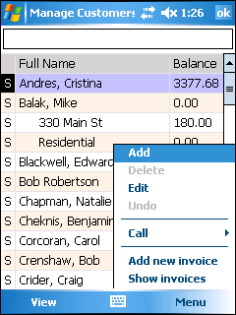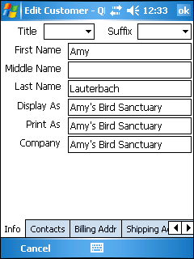

Left column of the customer list shows the status of customer record. "C" - Created, "S" - Synchronized and "M" - Modified. You can edit customer details disregard if it is synchronized or not. Editing synchronized customer changes its status to "modified" so you can apply undo operation to reset all the changes you made. You cannot delete modified or synchronized customer, but you can do this on the created customer. After next synchronization session all the changes will be uploaded to your QuickBooks Online account and their statuses will become synchronized.
If your Pocket PC supports phone you can make a call to a customer.
Q-Agent supports Invoice functionality. Press menu item “Add new invoice” to create new invoice for selected customer or “Show invoices” to view list of all available invoices.

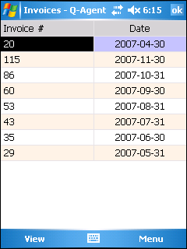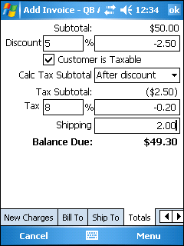

Banking

Banking hub allows you to write checks or enter credit card charges in the same way as on QuickBooks Online.

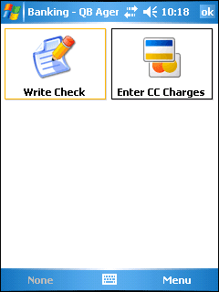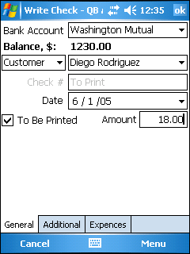

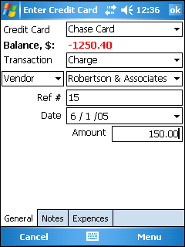

Accounts

Account hub shows the list of accounts with their current balance. Here you can also write check or enter credit card charges by selecting corresponding account from the list.

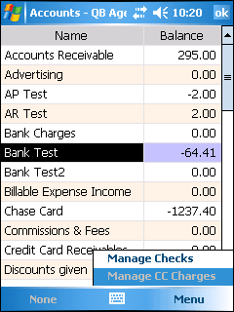

View Employees, Vendors and Item

These hubs give you the full list of employees, vendors and items. You cannot manage these entries, just view.

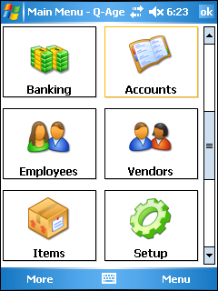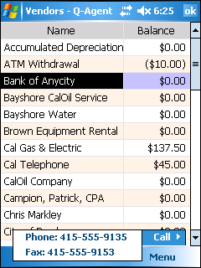

Setup

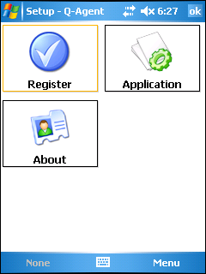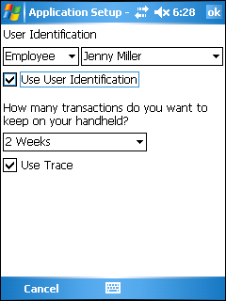

This hub allows you to register application, view application version and set different Q-Agent setting.
User Identification gives you ability to identify yourself as Employee or Vendor. This option takes effect on Manage Time hub (singe and weekly). If this option is turned on, only selected person will be available as time tracking person. This might be useful if you are usually creating time tracking records for 1 person and bored with switching person’s dropdown box every time. To turn this option on please select person type and name and check on “Use User Identification” check box. To turn this option off just uncheck “Use User Identification” check box.
Transaction freshness setting allows you not to keep all transaction records (such as invoices, check transactions, credit card transactions etc). This might be useful if your company contains lots of transaction data and you don’t want to keep them all on your handheld. Fewer amounts of transaction records reduce synchronization time and mobile database file size.

Quick Synchronization with QuickBooks® Online Edition

Use this hub to upload the changes you made and to get the latest data from your Quick Books Online account. Before synchronization, make sure you have an internet connection. You can use WiFi, GPRS or any other connection even ActiveSync with the host PC connected. Synchronization time can take several minutes and depends on amount of data.
After tapping "Start" you will be prompted for a password which you had entered during the installation. This password is used to decrypt your connection ticket. Also at the first time sync you will be prompted for entering transaction persistence. It allows you not to get all the transactions (such as Time Tracking, Invoices etc.) but get and keep the fresh data only. This setting could be changed at any time in "Application Setup" hub.
Synchronization works via SSL protocol which guarantees the safe connection.
When synchronization is finished you can review details for every synchronized record.

